**Programming Assignment Unit 3**

ANGELLA BENJAMIN

Bachelor's degree in Computer Science

CS 1101-01 Programming Fundamentals - AY2024-T2

Madhukeshwar Khanapur (Instructor)

05th December 2023

**Q.1 Part1:**  Recursive function countup that expects a negative argument and counts “up” from that number

The code below includes a function called countup that accepts an argument n. If the value of n is greater than or equal to 0, the function will print 'Blastoff!'. However, if the value of n is not 0, it will first print the value of n. In this example, the initial value of n is -3. The function then calls itself with n+1 as the argument, which increments n by 1. This process continues until n reaches 0, at which point 'Blastoff!' is printed because the condition n >= 0 is satisfied. Therefore, when countup(-3) is called, the output will be -3, -2, -1, and 'Blastoff!' in that order.

**Code.**

#recursive function countup

def countup(n):

    if n >= 0:

        print('Blastoff!')

    else:

        print(n)

        countup(n + 1)

countup(-3)

**Output**

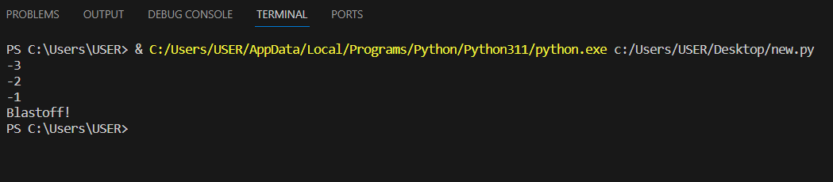

**Part 2:** Write a Python program that gets a number using keyboard input.

In this part of the assignment, I created a single function and used n == 0 as the condition to determine the behavior. If the sum of any number and n is equal to 0, the function will print "Blastoff!". If the number is greater than 0, the function will print the current value of n and recursively call itself with n - 1, decrementing n until it reaches 0 and then print "Blastoff!" since the condition is satisfied. Conversely, if the number is less than 0, the function will print the current value of n and recursively call itself with n + 1, incrementing n until it equals 0 and then print "Blastoff!".

This is a simplified approach I used to write the program with a single function to handle both countdown and count up. It is important to note that the value of n is obtained through user input. Therefore, the function counts up or down based on the number entered by the user.

**Here is the First code of implementation:**

def countdown_up(n):

    if n == 0:

        print('Blastoff!')

    elif n > 0:

        print(n)

        countdown_up(n - 1)

    else:

        print(n)

        countdown_up(n + 1)

n = int(input("Enter the number you want to count Up or Down: "))

countdown_up(n)

**Out of Positive Number**

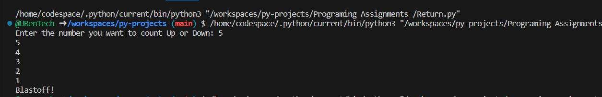

**Explanation**

* The function countdown_up(5) is called.
* Since n is greater than 0, it prints 5.
* Then, it calls countdown_up(4) with n - 1.
* This process continues until n becomes 0, and then it prints "Blastoff!".

**Output of A negative Number**

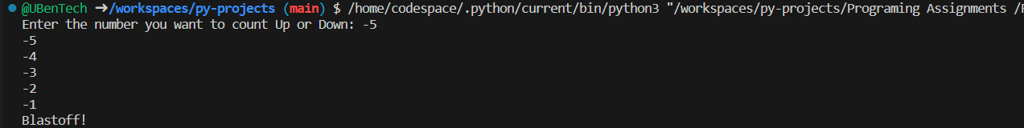

**Explanation**

* The function countdown_up(-5) is called.
* Since n is less than 0, it prints -5.
* Then, it calls countdown_up(-4) with n + 1.
* This process continues until n becomes 0, and then it prints "Blastoff!".

**Output of Zero**



**Explanation**

* The function countdown_up(0) is called.
* Since n equals 0, it directly prints "Blastoff!" without calling itself recursively.

**In summary:**

1. For n = 5, it counts down from 5 to 1, then prints "Blastoff!".
2. For n = -5, it counts up from -5 to -1, then prints "Blastoff!".
3. For n = 0, it directly prints "Blastoff!".

These outputs showcase how the recursive function countdown_up() operates based on the provided input values.

**Reference:**

<https://my.uopeople.edu/pluginfile.php/1807616/mod_page/content/4/TEXT%20-%20Think%20Python%202e.pdf>

<https://pythonprogramminglanguage.com/user-input-python/>

<https://realpython.com/python-recursion/>

<https://realpython.com/python-recursion/#get-started-count-down-to-zero>